**Water Monitoring Location Information**

**Phase-1 Development:**

|  |  |  |  |  |  |  |  |  |
| --- | --- | --- | --- | --- | --- | --- | --- | --- |
| **S. No.** | **Location** | **Number of Nodes** | **Node Location** | **Sensors planned** | **Constraints** | **Wi-Fi Availability** | **Comments** | **Status** |
| **1** | **Vindhya** | **4** | **RO Tank (SPCRC)** | **TDS,**  **Temperature** | **Extra Socket** | **YES** |  |  |
| **RO Tank (FDD Lab)** | **TDS,**  **Temperature** | **Probe Length must be changed.** | **YES** |  |  |
| **RO Tank (Third Floor)** | **TDS,**  **Temperature** | **Tile Walls, Extra Socket needed** | **YES** |  |  |
| **RO Tank (Third Floor)** | **TDS,**  **Temperature** | **Tile Walls, Extra Socket needed** | **YES** |  |  |
| **RO Tank (Third Floor)** | **TDS,**  **Temperature** | **Extra Socket needed** | **YES** |  |  |
| **2** | **Pump room-1 (at Main gate)** | **1** | **SUMP** | **TDS,**  **Temperature,**  **Water Flow** | **Extra Socket with wiring for power and probes** | **YES** |  |  |

**Planned in Further Phases:**

|  |  |  |  |  |  |  |  |  |  |  |
| --- | --- | --- | --- | --- | --- | --- | --- | --- | --- | --- |
| **S. No.** | **Location** | | **Number of Nodes** | | **Node Location** | **Sensor** | **Constraints** | **Wi-Fi Constraints** | **Comments** | **Status** |
| **3** | **Nilgiri** | | 1 | | **Sump** | **TDS, Temperature** | To be planned | To be planned |  |  |
| **4** | **Admin block, Himalaya range 'A' Block** | | 1 | | **Sump, SS Tanks** | **TDS, Temperature, Water Flow** | To be planned | To be planned |  |  |
| **5** | **Kohli Research Block, Himalaya 'B' Block** | | 1 | | **Sump, SS Tanks** | **TDS, Temperature** | To be planned | To be planned |  |  |
| **6** | **Bodh Bhavan, Himalaya 'C' Block** | | |  | **Sump, SS Tanks** | **TDS, Temperature** | To be planned | To be planned |  |  |
| **7** | **T-Hub (Himalaya 'D' Block)** | |  | | **Sump, SS Tanks** | **TDS, Temperature** | To be planned | To be planned |  |  |
| **8** | **Anand Nivas (Faculty & staff quarters)** | 1 | | | **Sump,** | **TDS, Temperature** | To be planned | To be planned |  |  |
| **1** | | | **Overhead tank** | **pH, Turbidity, Water level,** |
| **9** | **Budha Nivas (Faculty & staff quarters)** | 1 | | | **Sump** | **TDS, Temperature** | To be planned | To be planned |  |  |
| **10** | **Palash Nivas (Boys Hostel)** | **2** | | | **Sump** | **TDS, Temperature** | To be planned | To be planned |  |  |
| **1** | | | **Overhead Tank** | **pH, Turbidity, Water Level, Flow Sensor** |
| **11** | **Kadamba Nivas (Boys Hostel)** | **2** | | | **Sump** | **TDS, Temperature,**  **Water Flow** | To be planned | To be planned |  |  |
| **12** | **Parijath Nivas (Girls Hostel)** | **1** | | | **Overhead Tank** | **pH, Turbidity, Water Level, Water Flow** | To be planned | To be planned |  |  |
| **13** | **New women's Hostel-'A', 'B' & 'C' blocks** | **2** | | | **Sump & RO tank** | **TDS, Temperature** | To be planned | To be planned |  |  |
| **14** | **Bakul Nivas (Boys Hostel)** | **2** | | | **SS Tanks** | **TDS, Temperature** | To be planned | To be planned |  |  |
| **1** | | | **Overhead tank** | **pH, Turbidity, Water Level,** |
| **15** | **Sahana Atidhi Nivas (Guest House)** | **1** | | | **Pipes** | **Water Flow** | To be planned | To be planned |  |  |
| **16** | **Old Faculty Quarters** | **1** | | | **Pipes** | **Water Flow** | To be planned | To be planned |  |  |
| **17** | **Pump room-2 (at Sreenu canteen)** | **1** | | |  | **Water Flow** | To be planned | To be planned |  |  |
| **18** | **Pump room-3 (at FSQ)** | **1** | | |  | **Water Flow** | To be planned | To be planned |  |  |

**Phase-1 Development Location Pictures:**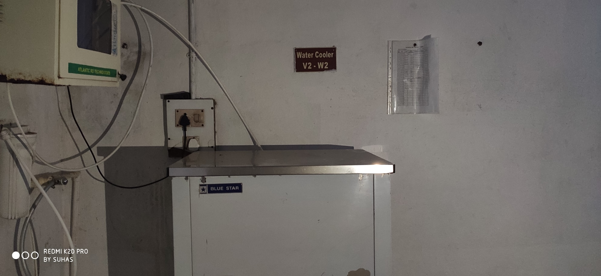

Figure VN00_01

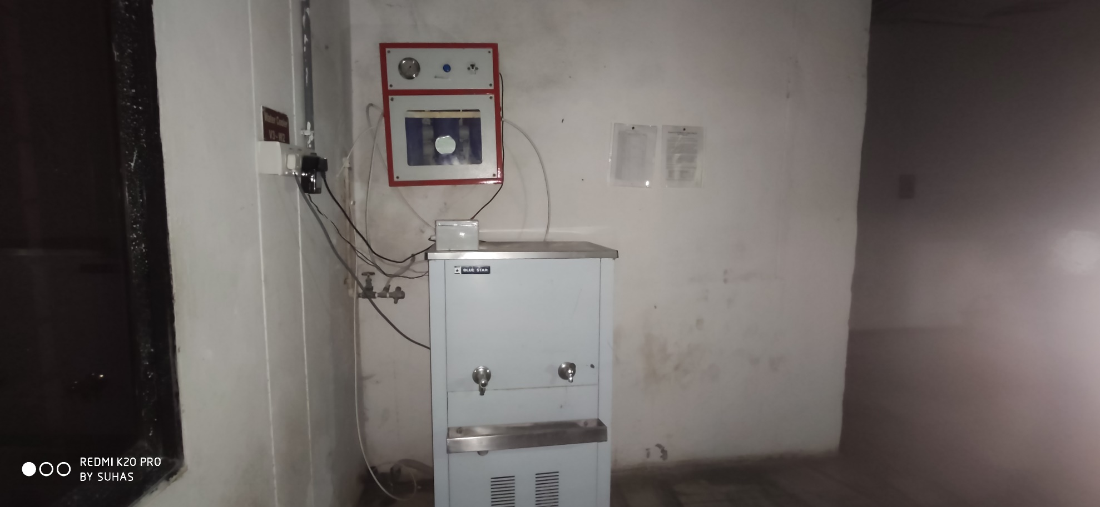

Figure VN00_02

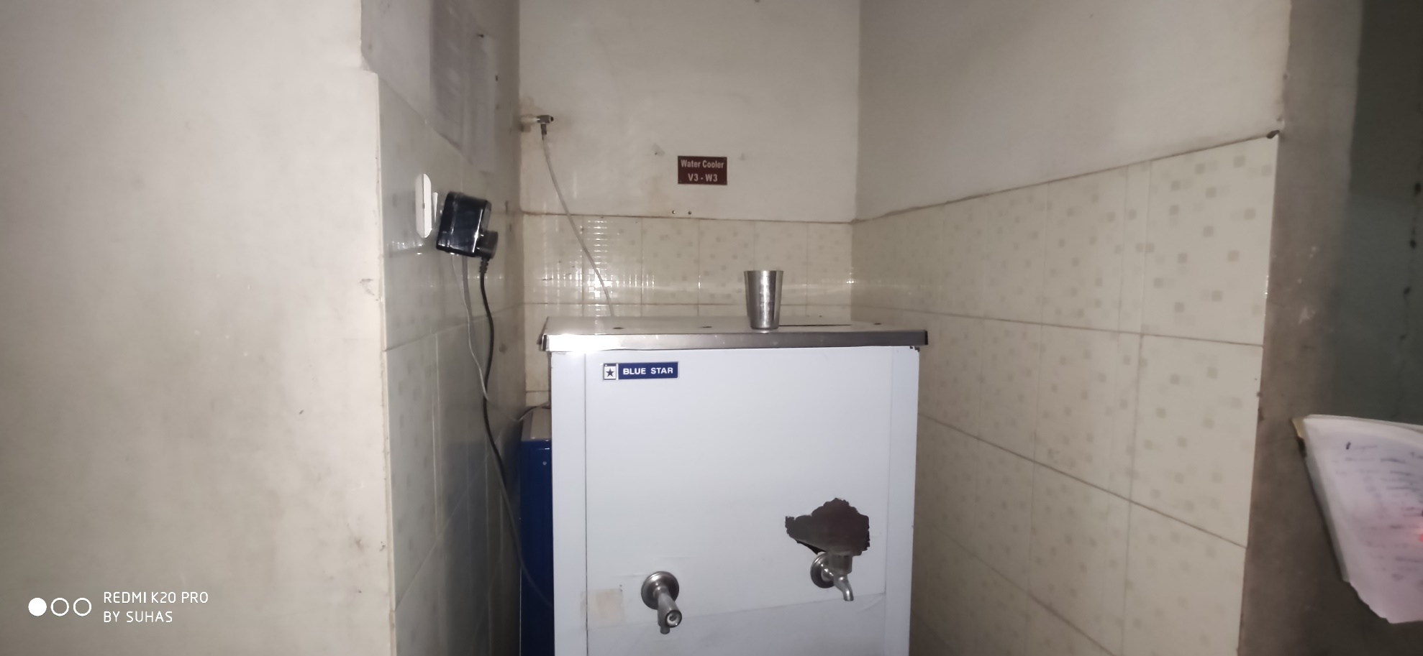

Figure VN00_03

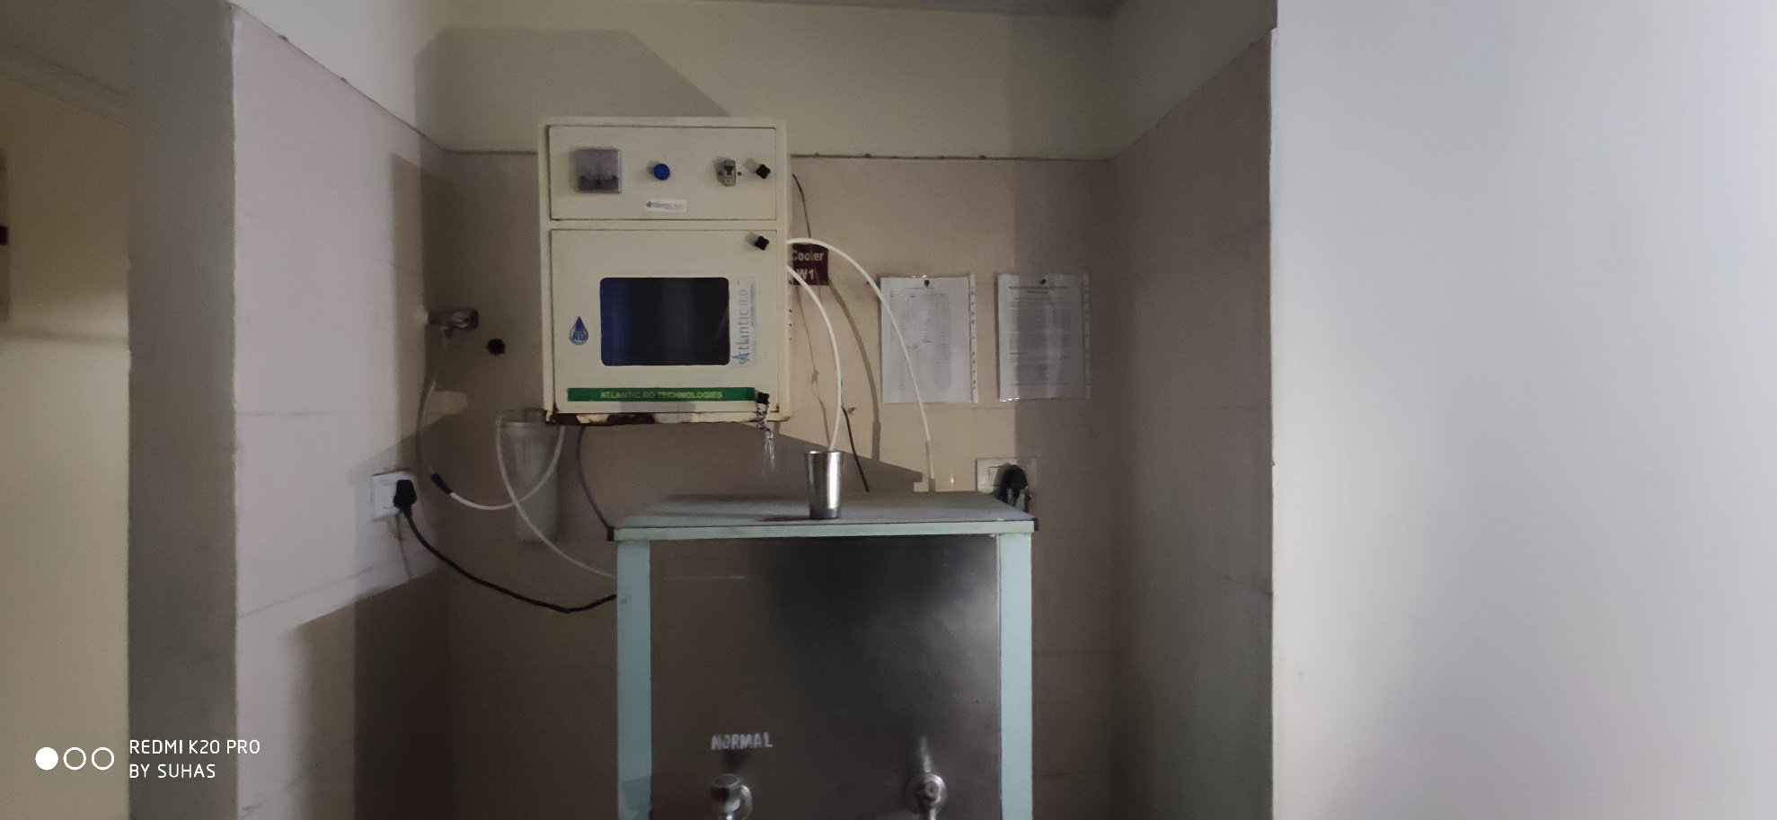

Figure VN00_04